Instructions to obtain a duplicate W-2:

Duplicate 2017 W2 Forms are available from the State of Maryland's on-line payroll website
(POSC) at: https://interactive.marylandtaxes.gov/extranet/cpb/posc/user/start.aspx
The University Agency Code (UMCP – 360222) and last pay check/advice number will be necessary
to create an account if you do not have an account. Otherwise, "Log On" with your credentials.
To look up your last Paystub (if you are signed up for direct deposit), go to:
https://bfs.umd.edu/commonlogin/login

Log In with your directory ID and click on the latest Biweekly Earning Statement

Copy the Check/Advice Number from the statement. Your agency code is 360222
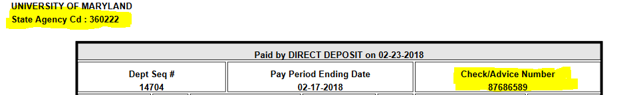
Beginning February 5, 2018 employees unable to access their W2 on POSC can call CPB directly to
request a duplicate tax form. The phone number is 410-260-7964.
The “2017 W2 What You Need To Know!” memo is available on the Comptroller of Maryland’s website
at: comptroller.marylandtaxes.gov/Government_Services/State_Payroll_Services/State_Employees/
NRA (non-resident alien) Employees’ 2017 1042-S Form
CPB will mail out 1042-S forms by March 15, 2018.
These tax forms only apply to those who in 2017 had one or more of the following:
• Used a foreign tax treaty
• Received a fellowship
• Received an honorarium
NRA Employees With Temporary SSN:
NRA employees that are issued a 2017 W2 and/or 1042-S Form with a temporary or incorrect SSN
should not file their tax return with the tax forms received from the State of Maryland.

