Click to select DATE

Click to type NEW HIRE NAME
Click to type STREET ADDRESS
Click to type CITY, STATE ZIP

Dear Click to type NEW HIRE NAME:

I am pleased to extend to you an offer of appointment as Click to type TITLE within the Click or type DEPT/UNIT at the University of Maryland, College Park. This is a tentative offer pending all necessary University approvals. The start date will be Click to type START DATE. The 12 month salary for this position is $Click to type SALARY AMOUNT (Click to type FTE% FTE). The probationary period for this appointment is for Click to select LENGTH OF PROBATION and your performance will be reviewed at regular intervals. You will be working under the direct supervision of Click to type SUPERVISOR’s NAME.

This is a regular Click to select FT/PT exempt staff appointment. As an exempt employee, you shall be expected to work a normal work week of no fewer than Click to type HOURS/WEEK hours per week from Monday through Friday. Your scheduled hours of work are from Click to type START & END TIMES. Employees in exempt positions are expected to work the hours necessary to complete assignments on a schedule that satisfies the requirements and responsibilities of the job. Employees in exempt positions are not entitled to compensation for hours in excess of 40 hours per week.

The University of Maryland values a diverse, united, proud, respectful, inclusive, accountable and empowered community of people from every background that works to impact positively our globally-connected society. As part of our commitment to those values, you will be expected to complete the TerrapinSTRONG onboarding program within two weeks of your first day of employment at the University. This new program will include a brief history of our institution; unconscious-bias and anti-racism training; diversity, equity and inclusion training; sexual harassment training; and an introduction to our cherished traditions.

The University of Maryland has made the safety of our students, faculty and staff, and our surrounding communities a top priority. As part of that commitment, the University System of Maryland (USM) recently announced that students, faculty, and staff on USM campuses this fall, including UMD, are required to be vaccinated against COVID. You are required to comply with the University's vaccination protocol or to request and be approved for a medical or religious exemption in order to work at any University of Maryland location. This offer of employment is contingent upon you providing proof of full vaccination or obtaining approval for a medical or religious exemption.

(For Employees New to Campus, or Returning after > 1 Year Break in Service )
Offers of employment are contingent on completion of a background check. A prior criminal conviction or convictions will not automatically disqualify a finalist from employment. Prior to any adverse decision, you will have an opportunity to provide information to the University regarding your background check. You will also be provided an opportunity to appeal any decision prior to a final outcome.

Employment, for regular University System of Maryland employees in exempt capacity, is on an at-will basis. All policies and procedures governing regular exempt employment can be found at the following website: http://www.president.umd.edu/policies/.

Click to select OPTIONAL AFSME WORDING or BLANK

Within approximately one month of your start date at the University, you will receive an assignment email asking you to complete a required online training program on Responding Effectively to Discrimination and Sexual Misconduct. The deadline for completing the training will be 30 days from
the date of your assignment email. Click to select OPTIONAL NO COMPUTER WORDING or BLANK

The University has an annual Performance Review and Development (PRD) process, which is a mechanism to provide ongoing interaction, to recognize performance and to identify training and development needs. Performance Review and Development (PRD) training is mandatory for all non-faculty employees and supervisors. PRD training is offered by University Human Resources (UHR) through a variety of training formats, including LinkedIn Learning. Information about the PRD and training can be found at https://uhr.umd.edu/performance-review-and-development-prd/.

As a regular exempt employee working 50% time or more, you are eligible to enroll in either the Maryland State Pension System or the Optional Retirement Program (ORP) with either Fidelity Investments or TIAA. Your decision to enroll in either plan is irrevocable. You must make a selection, and your enrollment forms must be dated, no later than your first day of employment or your retirement plan will automatically default to the Maryland State Pension System. If there is a default, a mandatory 7% of your pay will be deducted from your paycheck and this will be deemed an irrevocable decision. We encourage you to review the information at https://uhr.umd.edu/benefits/retirement-benefits/ or speak with a benefits counselor with the University Human Resources Office of Employee Benefits at (301) 405-7575 to assist you in making your selection no later than your first day of employment.

You are also eligible to receive health insurance benefits and participate in University-sponsored insurance programs. Please discuss your options with our Payroll Coordinator, Click to type PAYROLL COORDINATOR NAME (Click to type PAYROLL COORDINATOR PHONE #, Click to type PAYROLL COORDINATOR EMAIL). Paid leave is earned as follows (Note: if Part Time, leave is prorated based on FTE%): You will accrue 22 days of annual leave, 3 days of personal leave, 15 (or 16) designated holidays and 15 sick days per year. The holiday calendar can be found at https://phr-app6.umd.edu/holidays/. If you have not already completed your appointment paperwork with the department’s Payroll Coordinator, you will need to meet with them on your first day to finalize any remaining forms/tasks. Please see the checklist below for items that may be required on your first day. If you have any immediate questions about enrolling in benefits, please contact the department’s Payroll Coordinator listed above.

Please note: Insurance benefit coverage for all plans will be effective on the first day of the month following your date of hire, however you will be unable to enroll until you receive an email from the Employee Benefits Division that will give you access to enroll for benefits coverage. The email notification can take up to 30 days from your date of hire to become available to you. The normal processing time for online benefits request can take between 30-60 days from hire for your benefits to become active. Once the enrollment process is completed, you will be required to pay a mandatory retroactive payment of the premiums for the pay periods in which you did not have a payroll deduction, back to the effective date of coverage. Please contact the UHR Office of Employee Benefits for more information about this process at (301) 405-5654 or you can view their website at https://uhr.umd.edu/benefits.
For continuous insurance coverage to the end of the month in which you are hired, please make arrangements with your previous employer or health insurance carrier.
All new employees are encouraged to register for the University’s virtual New Employee Orientation & Welcome session which highlights university policies, resources, and tips to help navigate our large campus community. Presentations include a University of Maryland Overview, the Office of Employee Benefits and Local bargaining unit AFSCME 1072. A Zoom link to the orientation will be provided and handouts and other presentations will be available on Google Drive. To find the next Orientation session, visit the University’s New Employee webpage at https://uhr.umd.edu/new-employees/ and look for the link to the NEW Employee Orientations page or view the Events Calendar.

INSERT if new to campus:
If you require parking on campus, please contact our Parking Coordinator, Click to type PARKING COORDINATOR NAME (Click to type PARKING COORDINATOR PHONE #, Click to type PARKING COORDINATOR EMAIL). You will be assigned to park in Lot Click to type PARKING LOT ASSIGNMENT. In order to register you for parking, you will first need to be approved in the payroll system and then in the parking system. This approval process may take two full days. Until fully approved in both systems, you may park in the Xfinity Center Visitor lot or the visitor section of the Regents Drive Garage, which can be seen in the campus parking map provided below. Click to select 1st DAY PARKING OPTIONS https://transportation.umd.edu/parking/visitors.

On your first day please provide the make, model, year and license plate number to Click to type PARKING COORDINATOR NAME. Our Coordinator will ask DOTS to register your vehicle for you once you are in the payroll system. We will not be able to assign you to your parking lot until your vehicle is registered. The parking fee schedule can be found at https://transportation.umd.edu/parking/faculty-staff. If you elect to pay via payroll deduction, parking will only be deducted from 20 of the 26 pay periods per year. Payroll deductions are on a pre-tax basis and our Parking Coordinator can provide you with a payroll deduction enrollment form.

INSERT if already on campus:
Please let our Parking Coordinator, Click to type PARKING COORDINATOR NAME (Click to type PARKING COORDINATOR PHONE #, Click to type PARKING COORDINATOR EMAIL), know who handles parking for your previous position. Our Payroll Coordinator will work with your previous department and DOTS to transfer your parking registration over to Engineering.

INSERT if hired between mid-April to mid-August:
Payroll deduction for parking is not available during the summer months and the cutoff is normally in mid-April so you may not be eligible for payroll deduction until fall. We will work with DOTS to determine what your prorated parking amount will be for the remainder of the summer. Payment can be made online. In mid-August, we will contact you about completing a payroll deduction form to update your parking registration to an annual permit and set up payment for the remainder of the year.

On your first day, please report to Room Click to type ROOM NUMBER of the Click to type BUILDING NAME Building. If you have any further questions about the position or offer, please contact Click to type SUPERVISOR NAME (Click to type SUPERVISOR PHONE # , Click to type SUPERVISOR EMAIL). We are very excited about you joining the Click to type DEPT/UNIT NAME team. To accept this offer, please return a signed copy of this letter to your Supervisor and our Department Coordinator no later than Click or select ACCEPTANCE DEADLINE.

Sincerely,

Click or type NAME UNIT HEAD/AUTHORIZED SIGNATORY
Click or type TITLE UNIT HEAT/AUTHORIZED SIGNATORY

Your signature:

Click to type NEW HIRE’S NAME Date

CC: Click to type NAME UNIT BUSINESS OFFICER
Click to type NAME HIRING OFFICIAL
Click to type PAYROLL COORDINATOR

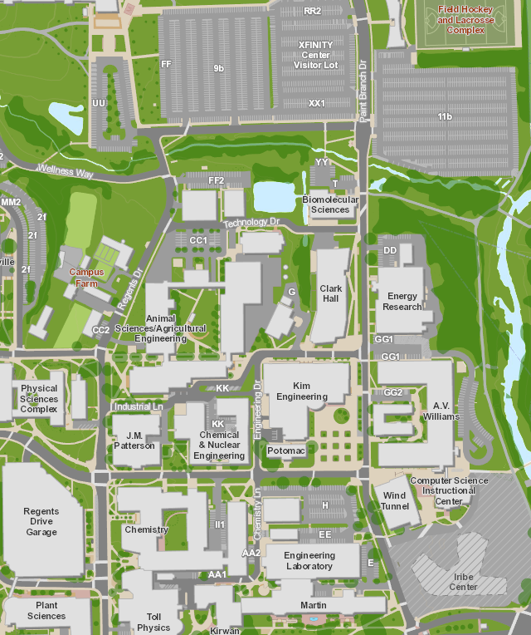

http://maps.umd.edu/map/

First Day Checklist

Welcome! On your first day with the Click to type DEPARTMENT/UNIT NAME, you will need to complete a number of forms. Some of these forms require you to bring items and/or information that you may not have readily available. Please use the guide below to ensure you are prepared on your first day:
☐ | I-9 Form Requirement: Bring your identification item(s). For a list of acceptable documents please visit https://www.uscis.gov/i-9-central/acceptable-documents.
☐ | Have your bank account information/account number(s) available to complete your direct deposit form.
☐ | Have your beneficiary information available: 1) Beneficiary Birthdate 2) Beneficiary Address 3) If Spouse, state/jurisdiction and date marriage license was issued.

☐ | Complete appropriate W4 form for tax withholding.

☐ | Bring your vehicle registration or make/model/year/license plate number, if you plan to register for parking.
☐ | Meet with our Payroll Coordinator, Click to type PAYROLL COORDINATOR NAME, in Room Click to type PAYROLL COORDINATOR ROOM# & BUILDING NAME Building, to complete necessary forms.

Thank you for helping us to ensure your first day goes smoothly!

